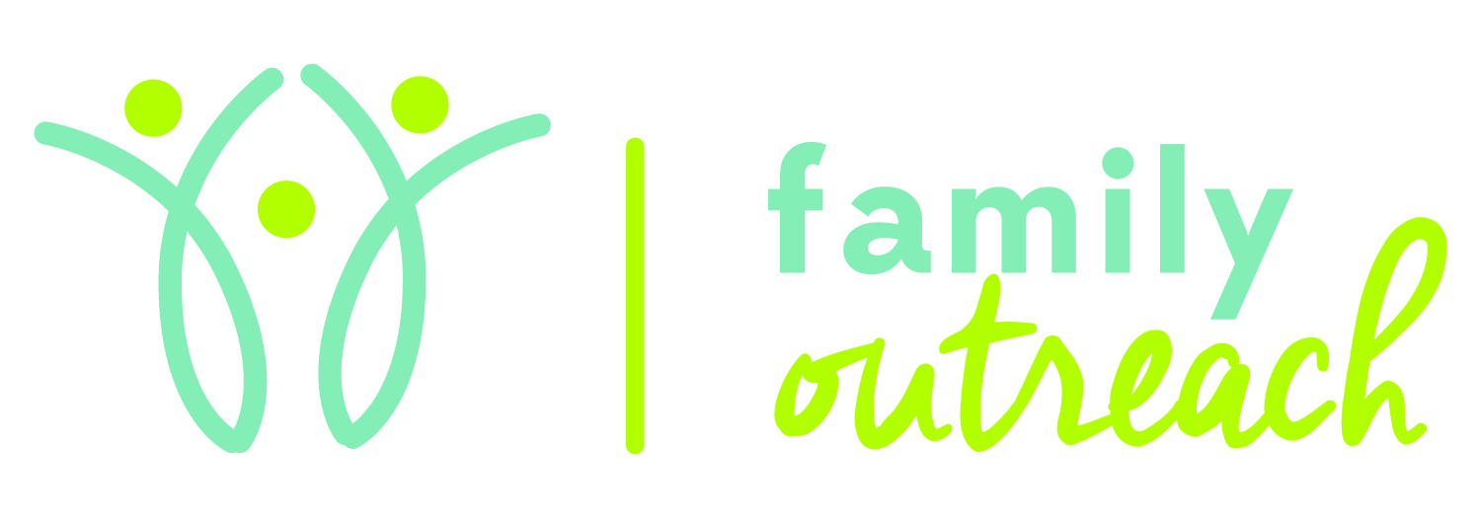

Please join Family Outreach
for an open house to celebrate the
Week of the Young Child.
April 18th 2018
9AM-3PM
1315 East Main St. Bozeman MT 59715
(406) 587-2477

- FREE developmental screenings for children ages 0-5
- Learn about how staff provide families with the resources, tools, and support they need for their child
- Information on Early Intervention services in the Community
- Snacks provided
Our Vision:
Provide innovative quality services to support people in achieving their potential for a full life.

